
SPORTS GALA 2025
UET LAHORE CS DEPARTMENT
GEAR UP FOR THE MOST EXCITING EVENT


OCTOBER 25, 2025
JUNAID JAMSHED STADIUM

Kindergarten Student Activities
Here are some fun and engaging activities designed for kindergarten students to help them learn, play, and grow in a creative environment.
Story Time:  Reading colorful pictures books aloud to children and asking simple question.  Read the pictures and write its name? | 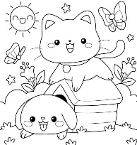 :________:_______
Arts and Crafts:  Using paper, crayons, glue, and scissors to create simple crafts like animals, flowers, or shapes to boost creativity and fine motor skills.  Use the material above described and create the following pictures. | 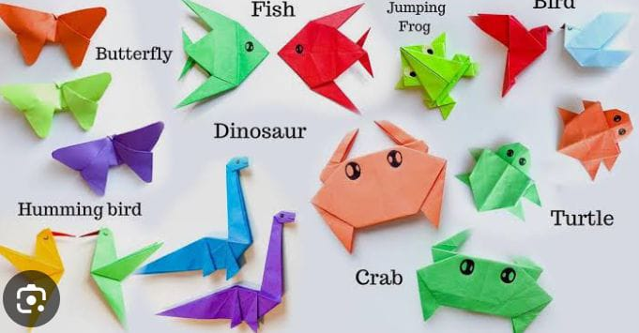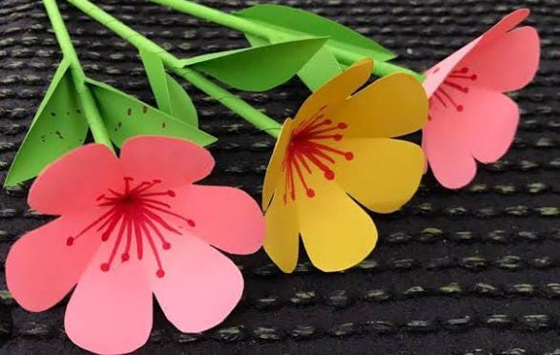
Sing-Along and Dance:  Singing nursery rhymes and dancing to fun tunes to improve memory, rhythm, and coordinates.  Sing the poems and rhyming words carefully.  And analyze it. | 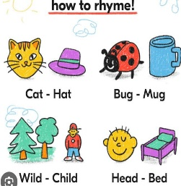
Puzzle Play:  Solving simple jigsaw puzzles or shape matching games to develop problem-solving  And thinking skill.  Solve the puzzle and match the correct picture. | 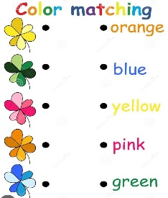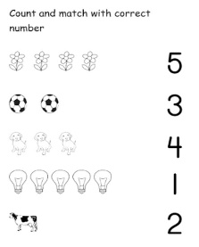
Outdoor Play:  Engaging in activities like running ball games, or hopscotch to encourage physical development and teamwork.  Play and name the following games. |  :_______ :________
Counting and sorting games:  Using blocks, beads, or toys to count, by sort by color/size, and recognize patterns for basic math skills | 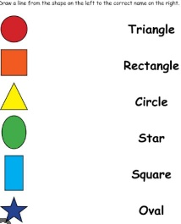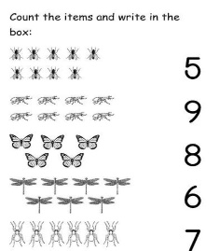

Gardening and Its Effects on Mental Health

References:

[1] | J. H. P. M. C. Jane Clatworthy, "Gardening as a mental health: A review," Mental Health Review Journal , vol. 18, no. 4, pp. 214 - 225, 2013.
[2] | A. Bahamonde, "Mental Health Through The Art of Gardening," Journal of Therapeutic Horticulture, vol. 29, no. 2, pp. 27 - 44, 2019.
[3] | S. Stuart-Smith, The Well-Gardened Mind: Rediscovering Nature in the Modern World, New York: Scribner, 2020.

My First Day Fooling at University
My first day at university was full of mixed emotions. I was both excited and nervous as I entered a new phase of life. The thought of meeting new people, exploring the campus, and starting fresh was thrilling. However, in the back of my mind, I was also anxious about the stories I had heard regarding seniors fooling juniors on their very first day.
As soon as I stepped into university, a group of senior students approached me with friendly smiles. They began unusual and funny questions which caught me off guard. Soon, they gave me tasks like singing loudly in the middle of the corridor, introducing myself in a silly way, and even pretending to be a professor delivering a lecture. At first, I felt embarrassed and shy, but I slowly realized it was all meant in good humor.
What seemed awkward in the beginning soon turned into an enjoyable experience? The laughter shared by seniors and juniors created a lively atmosphere, and I began to feel more comfortable in this new environment. It broke the ice and helped me make friends more easily. Though it was a little embarrassing, those moments became unforgettable memories that made my first day at university truly special.

BIO DATA FORM
Personal Information
Full Name
Father’s Name
Date of Birth
Gender
Nationality
CNIC / Passport No.
Marital Status
Contact Number

Address Details
Present Address
Permanent Address

Educational Qualifications
Degree | Institution | Year of Passing | Grade/Division

Work Experience
Organization | Position | Duration | Responsibilities

Declaration:
I hereby declare that the above information is true and correct to the best of my knowledge

Date: Signature:

Application to Chairman to change Discipline
To,
The Chairman,
[Department of Mathematics]
[University of Engineering and Technology]

Subject: Request for Change of Discipline

Respected Sir,

I respectfully request that I may be allowed to change my discipline from Mathematics to Computer Science. After careful consideration, I believe that the new discipline better matches my interests and future academic/career goals.

I assure you that I will continue to work with dedication and maintain good academic performance after the change.

I shall be very grateful for your kind consideration.

Thanking you in anticipation.

Yours obediently,
[Nabeeha Shoaib]
[1234567890]
[Semester 1]

